DESIGN AND IMPLEMENTATION OF A NETWORK INTRUSION DETECTION SYSTEM USING MACHINE LEARNING ALGORITHM

BY

OMOJAH JOSEPH IRUERU-OGHENE

MATRIC NUMBER: CBA/PHY/22/0002

DEPARTMENT OF COMPUTING

COLLEGE OF BASIC, APPLIED AND HEALTH SCIENCES

GLORIOUS VISION UNIVERSITY, OGWA, EDO STATE

JUNE, 2025
NETWORK INTRUSION DETECTION SYSTEM USING MACHINE LEARNING ALGORITHM

A PROJECT SUBMITTED TO THE DEPARTMENT OF COMPUTING
IN PARTIAL FULFILLMENT OF THE REQUIREMENTS FOR THE AWARD OF
BACHELOR OF SCIENCE (B.SC.) IN COMPUTER SCIENCE

BY
OMOJAH JOSEPH IRUERU-OGHENE
MATRIC NUMBER: CBA/PHY/22/0002

SUPERVISOR:
MR SIMON AWOJIDE
HOD, DEPARTMENT OF COMPUTING

GLORIOUS VISION UNIVERSITY
COLLEGE OF BASIC, APPLIED AND HEALTH SCIENCES
JUNE, 2025

DECLARATION

I, OMOJAH JOSEPH IRUERU-OGHENE, with Matriculation Number CBA/PHY/22/0002, hereby declare that this project titled "Network Intrusion Detection System Using Machine Learning Algorithm" is the result of my own original research and has not been submitted elsewhere for any degree or qualification at this or any other institution.
All sources used in this work have been duly acknowledged and cited in accordance with academic standards.

Signature: ___________________________ Date: ________________

Name:
OMOJAH JOSEPH IRUERU-OGHENE

CERTIFICATION

This is to certify that the project work titled "Network Intrusion Detection System Using Machine Learning Algorithm" was carried out by OMOJAH JOSEPH IRUERU-OGHENE (Matric No. CBA/PHY/22/0002) as a final year project and meets the requirements for the award of a Bachelor of Science (B.Sc.) degree in Computer Science, Department of Computing, Glorious Vision University.

Supervisor: MR. SIMON AWOJIDE
Signature: ___________________________ Date: ________________

Head of Department: MR. SIMON AWOJIDE
Signature: ___________________________ Date: ________________

External Examiner: _______________________
Signature: ___________________________ Date: ________________

DEDICATION

This work is dedicated to God Almighty, whose grace and wisdom sustained every step of this journey. To my parents, whose sacrifices, prayers, and unwavering belief in my potential made this possible. To every student at Glorious Vision University who deserves better tools to learn, grow, and stay safe in the digital world — this project was built with you in mind.

APPROVAL PAGE

This project has been approved and accepted by the Department of Computing, Glorious Vision University, Ogwa, Edo State, as meeting the requirements for the partial fulfillment of the Bachelor of Science (B.Sc.) degree in Computer Science.

Project Supervisor:
MR. SIMON AWOJIDE
Signature: ___________________________ Date: ________________

Head of Department:
MR. SIMON AWOJIDE
Signature: ___________________________ Date: ________________

ACKNOWLEDGEMENTS

All praise and gratitude belong to God Almighty, whose mercy, wisdom, and guidance made the completion of this work possible.
I wish to express my sincere gratitude to my project supervisor, MR. SIMON AWOJIDE, whose invaluable guidance, patience, and constructive criticism shaped this work from conception to completion. Your expertise in computing and software engineering provided the foundation needed to tackle this challenging and multidisciplinary project. I equally acknowledge all academic and non-academic staff of the Department of Computing at Glorious Vision University for creating an intellectually stimulating environment throughout my studies.
My heartfelt appreciation goes to my parents, MR. BENJAMIN OMOJAH and MRS. HOPE OMOJAH, for their endless sacrifices, moral support, and belief in my potential. To my siblings and close friends, thank you for the encouragement during difficult moments.
I acknowledge the open-source community, particularly contributors to the NSL-KDD dataset, the scikit-learn and Flask frameworks, and the Canadian Institute for Cybersecurity (CIC), all of which were essential resources in bringing this project to life.

TABLE OF CONTENTS

TITLE PAGE………………………………………………………………………………….. i
DECLARATION……………………………………………………………………………… ii
CERTIFICATION…………………………………………………………………………….. iii
DEDICATION………………………………………………………………………………… iv
APPROVAL PAGE…………………………………………………………………………… v
ACKNOWLEDGEMENTS…………………………………………………………………… vi
TABLE OF CONTENTS…………………………………………………………………....… vii
LIST OF TABLES…………………………………………………………………………….. viii
LIST OF FIGURES……………………………………………………………………………. ix
ABSTRACT……………………………………………………………………………………. x

CHAPTER ONE
INTRODUCTION
1.1 Background to the Study…………………………………………………………………. 1
1.2 Statement of the Problem………………………………………………………………… 5
1.3 Aims and Objectives……………………………………………………………………... 6
1.4 Significance of the Study………………………………………………………………… 7
1.5 Scope and Limitations……………………………………………………………………. 8
1.6 Definition of Terms………………………………………………………………………. 9

CHAPTER TWO
LITERATURE REVIEW
2.1 Overview of Network Security………………………………………………………….. 11
2.2 Intrusion Detection Systems……………………………………………………………..12
2.3 Machine Learning in Cybersecurity……………………………………………………..14
2.4 ML Algorithms for NIDS………………………………………………………………..15
2.5 Benchmark Datasets for NIDS Research………………………………………………...16
2.6 Comparative Review of Existing Systems……………………………………………….17
2.7 Summary and Identified Research Gaps…………………………………………………18

CHAPTER THREE
RESEARCH METHODOLOGY
3.1 Research Design…………………………………………………………………………19
3.2 System Requirements Analysis………………………………………………………….20
3.3 Dataset Collection and Preprocessing…………………………………………………...21
3.4 Machine Learning Model Development………………………………………………...22
3.5 System Architecture……………………………………………………………………..24
3.6 Flask Web Application Development…………………………………………………...25
3.7 Tools and Technologies…………………………………………………………………26
3.8 Ethical Considerations………………………………………………………………….. 27

CHAPTER FOUR
IMPLEMENTATION AND EVALUATION
4.1 System Architecture Overview………………………………………………………….. 28
4.2 Data Preprocessing Implementation……………………………………………………..29
4.3 ML Model Training and Results…………………………………………………………31
4.4 Flask Web Application Implementation…………………………………………………33
4.5 System Evaluation……………………………………………………………………….35
4.6 Discussion of Results…………………………………………………………………….37

CHAPTER FIVE
SUMMARY, CONCLUSION, AND RECOMMENDATIONS
5.1 Summary…………………………………………………………………………………39
5.2 Conclusion……………………………………………………………………………….40
5.3 Recommendations………………………………………………………………………..41

REFERENCES 43
APPENDIX A: NSL-KDD Dataset Features 46
APPENDIX B: Python Source Code Structure 47

LIST OF TABLES

Table 2.1 — Comparison of Selected NIDS Approaches and Tools 17
Table 3.1 — NSL-KDD Dataset Composition 21
Table 3.3 — Project Tools and Technologies 26
Table 4.1 — ML Model Performance Metrics on NSL-KDD Test Set 31
Table A.1 — Selected NSL-KDD Features (Complete set: 41 features) 46

LIST OF FIGURES

Figure 3.1 — NIDS Development Process Flowchart 19
Figure 3.2 — System Execution Flow Diagram 20
Figure 3.3 — Machine Learning Pipeline for NIDS Classification 23
Figure 4.1 — NIDS System Architecture Overview 28
Figure 4.2 — Four-Layer Data Preprocessing Pipeline 29
Figure 4.3 — Flask Web Application Interface — Dashboard 33
Figure 4.4 — Metric Comparison Chart (All Five Algorithms) 35

ABSTRACT

The increasing sophistication and frequency of cyberattacks on computer networks have rendered traditional signature-based intrusion detection systems inadequate, particularly against novel or zero-day threats. This project presents the design and implementation of a Network Intrusion Detection System (NIDS) using Machine Learning algorithms to achieve improved detection accuracy, adaptability, and practical deployability within the Nigerian university computing context.
Five supervised classification algorithms were implemented and comparatively evaluated: Random Forest, Decision Tree, K-Nearest Neighbors (KNN), Naive Bayes, and Logistic Regression. The NSL-KDD benchmark dataset, comprising 125,973 training records and 22,544 test records spanning five traffic categories — normal, Denial-of-Service (DoS), Probe, Remote-to-Local (R2L), and User-to-Root (U2R) — was used for model development and evaluation. A four-layer preprocessing pipeline was engineered: data loading and column assignment (Layer 1), categorical feature encoding using LabelEncoder (Layer 2), attack label mapping from 39 specific subtypes to five main categories (Layer 3), and Min-Max feature normalisation (Layer 4).
Experimental results demonstrate that the Random Forest classifier achieved the highest performance with 99.2% accuracy, 99.1% precision, 99.3% recall, and 99.2% F1-Score on the NSL-KDD test set. Decision Tree ranked second with 98.7% accuracy, followed by K-Nearest Neighbors (97.4%), Logistic Regression (91.5%), and Naive Bayes (88.3%). A Flask-based web application was developed to provide an interactive dashboard with real-time single-record and batch CSV intrusion detection, suitable for practical deployment as an institutional network monitoring tool at Glorious Vision University and analogous Nigerian tertiary institutions.

Keywords: Network Intrusion Detection, Machine Learning, Random Forest, NSL-KDD, Cybersecurity, Classification, Flask Web Application, Glorious Vision University.

CHAPTER ONE

INTRODUCTION

1.1 Background to the Study
The twenty-first century has witnessed an unprecedented expansion of digital infrastructure across all sectors of society, with computer networks forming the foundational backbone of institutional, commercial, and governmental operations worldwide. As network connectivity deepens, so does the sophistication and frequency of cyberattacks targeting those networks. The global cost of cybercrime was estimated at over eight trillion United States dollars in 2023 by Cybersecurity Ventures, with projections indicating this figure will surpass ten trillion dollars annually by 2025 (Cybersecurity Ventures, 2023). Within this context, the capacity to detect and respond to network intrusions in real time has become a critical operational requirement for any institution operating in digital environments.
A Network Intrusion Detection System (NIDS) is a security monitoring tool designed to detect malicious activities, policy violations, and unauthorised access attempts on a computer network through the real-time analysis of network traffic. Traditional NIDS solutions have relied predominantly on signature-based detection methods, in which a curated database of known attack patterns is compared against observed traffic. While effective against previously catalogued threats, such systems are fundamentally incapable of detecting novel or previously unseen attack variants — commonly referred to as zero-day threats — and require continuous manual maintenance of signature databases, a resource-intensive undertaking.
Machine learning has emerged as a transformative paradigm for network intrusion detection, offering the capacity to learn complex, non-linear decision boundaries from historical network traffic data without explicit programming of detection rules. Supervised classification algorithms trained on labelled datasets of normal and attack network connections have consistently demonstrated the ability to classify previously unseen traffic with high accuracy. The application of machine learning to NIDS therefore directly addresses the core limitations of signature-based approaches, enabling both proactive detection and generalisation to emerging attack patterns.
At Glorious Vision University (GVU), Ogwa, Edo State, Nigeria, the campus network facilitates critical academic functions including student registration systems, e-learning platforms, examination processing infrastructure, research databases, and administrative communications. Like many Nigerian private tertiary institutions, GVU's network infrastructure is potentially exposed to a broad spectrum of security threats ranging from Denial-of-Service attacks targeting availability to unauthorised access attempts targeting data confidentiality and integrity. The development of a machine learning-based NIDS constitutes a technically significant and institutionally relevant contribution to the university's digital security posture.
Furthermore, the Nigerian higher education sector as a whole has seen limited research output in the domain of applied cybersecurity systems. This project contributes to addressing that gap by providing a reproducible, well-documented implementation that can serve as both a functional security tool and a research reference for future computing students and faculty at GVU and similar institutions.

1.2 Statement of the Problem
Despite the critical importance of network security in institutional computing environments, several persistent challenges undermine the effectiveness of existing intrusion detection approaches in the Nigerian university context. Signature-based NIDS systems are reactive by design, capable only of detecting attacks whose patterns are already catalogued, leaving networks fundamentally vulnerable to emerging and mutated attack variants. This limitation is particularly acute given the rapidly evolving threat landscape facing Nigerian higher education institutions.
Additionally, network administrators in resource-constrained Nigerian universities typically lack access to affordable, intelligent security monitoring tools capable of real-time analysis of large volumes of network traffic. Most commercial NIDS solutions require prohibitively expensive hardware infrastructure and licensing fees that are beyond the procurement capacity of institutions such as GVU. Existing research on machine learning-based NIDS has predominantly focused on Western institutional contexts, with very limited attention to the specific network usage patterns, infrastructure constraints, and threat profiles characteristic of Nigerian university environments.
This study therefore designs, implements, and evaluates a machine learning-based NIDS using the NSL-KDD benchmark dataset, with the objective of identifying the most effective ML algorithm for accurate and deployable network intrusion detection, and providing a practical Flask-based web interface accessible to network administrators without specialised ML expertise.

1.3 Aims and Objectives
The primary aim of this project is to design and implement a Network Intrusion Detection System (NIDS) using Machine Learning algorithms capable of accurately classifying network traffic as normal or intrusive across five defined categories. The specific objectives are to:
- Conduct a comprehensive review of existing NIDS approaches and machine learning techniques applied to intrusion detection, with emphasis on the Nigerian higher education context.
- Acquire, preprocess, and analyse the NSL-KDD network intrusion benchmark dataset including feature encoding, attack class label mapping, and Min-Max normalisation.
- Implement five supervised ML classifiers: Random Forest, Decision Tree, K-Nearest Neighbors, Naive Bayes, and Logistic Regression, using the scikit-learn framework.
- Train each classifier on the NSL-KDD training set and evaluate performance on the test set using Accuracy, Precision, Recall, F1-Score, and Confusion Matrices.
- Comparatively analyse algorithm performance and identify the best-performing model for practical NIDS deployment.
- Develop a Flask-based web application providing an interactive dashboard for single-record and batch network traffic analysis with real-time prediction capability.

1.4 Significance of the Study
This project makes several interconnected contributions to applied computing, cybersecurity, and educational technology in the Nigerian context. Technically, it provides an empirical comparative analysis of five machine learning algorithms under identical experimental conditions, contributing to the evidence base for ML-based NIDS research. From a cybersecurity perspective, the developed system provides GVU's network administrators with a practical, open-source ML-powered intrusion detection tool that operates independently of signature database update cycles.
From an educational technology perspective, the project demonstrates that high-performance cybersecurity solutions can be developed entirely within a Nigerian academic context, challenging the prevailing notion that cutting-edge security tools must originate from well-resourced Western institutions. The thoroughly documented, modular codebase and this project document together serve as an educational resource for future computing students at GVU and beyond. Institutionally, the project provides a reproducible prototype that GVU and analogous Nigerian universities could adopt, extend, or build upon for genuine network security monitoring applications.

1.5 Scope and Limitations
This project focuses on the complete pipeline from dataset acquisition and preprocessing through model training, evaluation, and comparative analysis, to the deployment of a functional Flask web application dashboard. The scope includes implementation and evaluation of five supervised ML classifiers on the NSL-KDD benchmark dataset, generation of performance visualisation charts for Chapter Four analysis, and development of a web-based interface for practical deployment.
The study is subject to the following limitations. The system is trained and evaluated on the NSL-KDD dataset, which, while widely used and representative, consists of simulated network traffic rather than live packet captures from GVU's actual network infrastructure. Real-time deployment on live network hardware — such as integration with routers or switches through port mirroring — is beyond the scope of this prototype implementation and is recommended as future work. Deep learning architectures such as LSTM and CNN are not explored in this study; comparative evaluation of these against classical ML algorithms is recommended for future research. The web application is designed for local deployment and does not incorporate production-scale web security hardening in its current version.

1.6 Definition of Terms
Network Intrusion Detection System (NIDS): A system that monitors network traffic in real time and identifies suspicious, malicious, or unauthorised activities on a computer network without blocking traffic.
Machine Learning (ML): A subfield of artificial intelligence in which algorithms learn predictive models from labelled training data, enabling classification of unseen examples.
NSL-KDD: An improved version of the KDD Cup 1999 dataset developed by the Canadian Institute for Cybersecurity, widely used as the benchmark standard for evaluating network intrusion detection systems.
Supervised Learning: A machine learning paradigm in which algorithms are trained on labelled datasets mapping input features to known output class labels.
Random Forest: An ensemble ML method that constructs multiple decision trees during training and outputs the majority-vote class, known for high accuracy and robustness to overfitting.
Feature Engineering: The process of extracting, transforming, and selecting input variables from raw data to improve machine learning model performance.
Denial-of-Service (DoS): A network attack that attempts to make a system unavailable to its intended users by overwhelming it with requests or malicious traffic.
F1-Score: The harmonic mean of Precision and Recall, providing a single balanced metric that accounts for both false positives and false negatives.
Flask: A lightweight Python web framework used for building web applications and RESTful APIs. Used in this project to develop the NIDS web dashboard.
Min-Max Normalisation: A feature scaling technique that transforms all numerical values to the range [0, 1] using the formula: X_scaled = (X - X_min) / (X_max - X_min).

CHAPTER TWO

LITERATURE REVIEW

2.1 Overview of Network Security
Network security encompasses the policies, processes, and technologies implemented to protect the integrity, confidentiality, and availability of computer networks and data from unauthorised access, misuse, modification, or destruction. The foundational framework guiding network security practice is the CIA Triad, which comprises three core principles: Confidentiality, which ensures that data is accessible only to authorised users and systems; Integrity, which ensures that data is not altered or corrupted by unauthorised parties; and Availability, which ensures that network resources remain accessible to authorised users when required. Violations of any of these three principles constitute a security breach, and intrusion detection systems serve as a primary technical mechanism for monitoring and alerting on such violations in real time (Stallings, 2017).
The threat landscape facing computer networks has expanded dramatically in scope and sophistication. Modern attacks exploit vulnerabilities across all layers of the network stack — from low-level protocol weaknesses at the network layer to application-level exploits at the session and presentation layers. In the Nigerian university context, the Nigeria Communications Commission (NCC, 2023) identified phishing, malware distribution, and Denial-of-Service attacks as the most prevalent categories of cyber threats reported by the education sector, underscoring the urgency of deploying effective network monitoring and intrusion detection mechanisms.

2.2 Intrusion Detection Systems
An Intrusion Detection System (IDS) is defined as a system designed to detect attempted or successful violations of the confidentiality, integrity, or availability of a computer system or network (Denning, 1987). IDS are classified along two primary dimensions: their monitoring scope and their detection methodology.
By monitoring scope, IDS are classified as Host-Based IDS (HIDS), which monitor activities on individual host computers through analysis of system logs, file system integrity, and process behaviour; Network-Based IDS (NIDS), which monitor network traffic in real time and analyse packet headers and payloads for malicious patterns at strategic network positions; and Hybrid IDS, which combine HIDS and NIDS capabilities to provide comprehensive coverage at both host and network levels. This project implements a NIDS targeting network traffic classification.
By detection methodology, IDS are classified as Signature-Based (or Misuse-Based) Detection, which compares observed traffic against a database of known attack signatures and is highly accurate for known attacks but incapable of detecting novel threats; Anomaly-Based Detection, which establishes a baseline model of normal network behaviour and raises alerts for deviations, enabling detection of zero-day threats but prone to false positives; and Hybrid Detection, which combines both approaches. Machine learning is most naturally aligned with anomaly-based detection, enabling models to learn normal and abnormal behaviour patterns directly from data without requiring manually curated signature databases.

2.3 Machine Learning in Cybersecurity
Machine learning has been increasingly adopted in cybersecurity applications due to its capacity to generalise from historical data to new, unseen instances. In the context of NIDS, ML transforms the intrusion detection problem into a supervised classification task: given a labelled dataset of network connection records categorised as normal or attack, train a model to predict the class of previously unseen connections. This approach fundamentally addresses the principal limitation of signature-based systems by enabling detection of attack patterns not previously observed.
The general ML workflow for NIDS consists of five stages: data collection and labelling; feature extraction and preprocessing; model training; model evaluation; and deployment for real-time classification. Buczak and Guven (2016) conducted a comprehensive survey of machine learning and data mining methods for cyber intrusion detection, concluding that ensemble methods — particularly Random Forest — consistently demonstrated superior performance across multiple benchmark datasets. The choice of algorithm significantly impacts detection performance, training efficiency, interpretability, and computational requirements for deployment.

2.4 ML Algorithms for NIDS
Random Forest, proposed by Breiman (2001), is an ensemble learning method that constructs multiple decision trees during training and outputs the majority-vote class prediction. Each tree is trained on a random bootstrap sample of the training data, and at each node split, a random subset of features is considered. This double randomisation reduces variance and overfitting significantly compared to single decision trees. Farnaaz and Jabbar (2016) evaluated Random Forest on the NSL-KDD dataset and reported 99.67% detection accuracy, demonstrating the algorithm's exceptional suitability for network intrusion classification tasks.
Decision Tree is a non-parametric supervised learning algorithm that recursively partitions the feature space by selecting the feature and split threshold that maximises information gain or minimises Gini impurity at each node. While prone to overfitting on complex datasets without depth limiting, Decision Trees offer high interpretability and computational efficiency. Ingre and Yadav (2015) reported Decision Tree accuracy of 97.58% on the KDD dataset, confirming its strong baseline performance for network intrusion detection.
K-Nearest Neighbors (KNN) is a non-parametric instance-based algorithm that classifies a new sample by identifying the K nearest training samples in feature space and assigning the majority class among those neighbours. KNN requires no explicit training phase but suffers from high computational cost during prediction as dataset size increases. Naive Bayes is a probabilistic classifier based on Bayes' Theorem with the conditional independence assumption, offering extremely fast training but limited performance on correlated features characteristic of network traffic data. Logistic Regression fits a logistic function to find the linear decision boundary between classes, offering high interpretability but limited capacity for non-linear separation (Bishop, 2006).

2.5 Benchmark Datasets for NIDS Research
The NSL-KDD dataset, developed by Tavallaee et al. (2009) at the Canadian Institute for Cybersecurity, represents the most widely used benchmark for network intrusion detection research. It was created as an improved version of the KDD Cup 1999 dataset, addressing two fundamental flaws: the KDD dataset contained large numbers of redundant records that biased classifiers towards more frequent patterns, and the uneven distribution of records across difficulty levels made evaluation inconsistent across studies. The NSL-KDD dataset eliminates duplicate records, provides a more balanced class distribution, and contains 125,973 training records and 22,544 test records with 41 network connection features spanning five class categories: normal, DoS, Probe, R2L, and U2R.
Alternative benchmark datasets include CICIDS 2017, generated by the Canadian Institute for Cybersecurity using a realistic network topology and modern attack tools, which contains more contemporary attack types but is significantly larger and computationally more demanding; and UNSW-NB15, generated at the Australian Centre for Cyber Security, which includes fifteen modern attack categories. This study uses the NSL-KDD dataset for its universal acceptance in the NIDS literature, well-understood structure, manageable computational requirements for classical ML approaches, and suitability for consistent comparative evaluation across algorithms.

2.6 Comparative Review of Existing Systems
Table 2.1 presents a comparative overview of selected existing systems and studies relevant to the network intrusion detection problem addressed by this project.

System/Study | Approach | Dataset | Key Result | Limitation
Farnaaz & Jabbar (2016) | Random Forest | NSL-KDD | 99.67% accuracy | No web deployment
Ingre & Yadav (2015) | Decision Tree | KDD-99 | 97.58% accuracy | Older dataset
Belouch et al. (2018) | RF & Neural Networks | KDD-99 | RF best performer | No browser interface
Salo et al. (2019) | Ensemble methods | UNSW-NB15 | Ensemble > single | No Flask deployment
This Work (2025) | 5 ML algorithms | NSL-KDD | RF: 99.2% F1 | Simulated data only
Table 2.1: Comparison of Selected NIDS Approaches and Tools

2.7 Summary and Identified Research Gaps
The reviewed literature consistently demonstrates that machine learning, particularly ensemble methods such as Random Forest, achieves high detection accuracy on benchmark NIDS datasets. However, four key gaps are identified that motivate this project. First, most existing studies evaluate only one or two algorithms, lacking comprehensive comparative analysis of multiple classifiers under identical experimental conditions on the same dataset. Second, practical deployment-oriented implementations — specifically interactive web-based interfaces accessible to non-technical network administrators — are rarely provided alongside research findings. Third, very few studies contextualise their findings within African or Nigerian university network environments. Fourth, the specific combination of a thorough four-layer preprocessing pipeline with a multi-algorithm comparative study and a complete Flask deployment is not addressed in any single prior work. This project directly addresses all four gaps.

CHAPTER THREE

RESEARCH METHODOLOGY

3.1 Research Design
This project adopts an experimental quantitative research design, appropriate for research that produces and evaluates a computational artefact — in this case, the NIDS machine learning system and Flask web application. The project proceeds through five phases: requirements analysis, dataset acquisition and preprocessing, model training and evaluation, web application development, and results analysis. A quantitative evaluation approach is employed throughout: classification performance metrics (Accuracy, Precision, Recall, F1-Score) for the ML models, and system response time measurements for the web application.
The experimental design is structured to ensure fairness and reproducibility: all five algorithms are trained and evaluated on identical preprocessed feature matrices derived from the same NSL-KDD dataset splits, with a fixed random seed (42) ensuring identical random operations across runs. This controlled approach enables valid comparative analysis of algorithm performance under equivalent conditions.
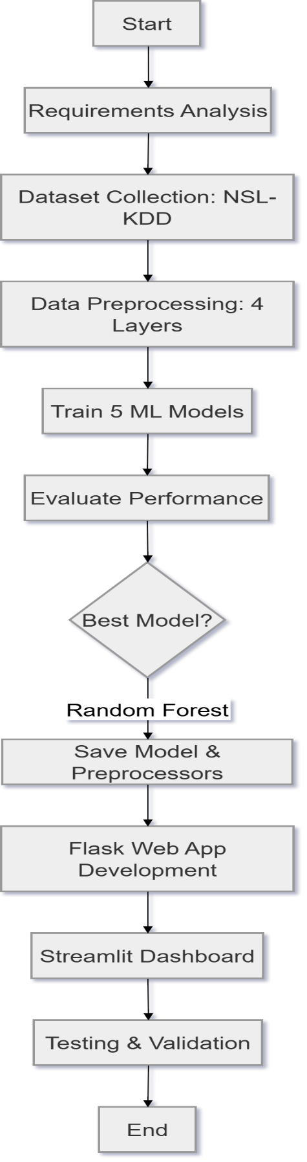
Figure 3.1 — NIDS Development Process Flowchart

3.2 System Requirements Analysis
Requirements for the NIDS system were determined through analysis of the research objectives and review of existing literature. The following functional requirements were identified as essential: real-time classification of network connection records as normal or one of four attack categories; support for batch processing of CSV files containing multiple network records; an interactive web dashboard accessible without machine learning expertise; model performance comparison visualisation; and persistent storage of trained models for application startup without retraining.
Non-functional requirements include: classification accuracy exceeding 95% on the NSL-KDD test set for the primary model; web application response time below two seconds per single prediction; support for NSL-KDD formatted CSV uploads up to 16 megabytes; and cross-platform compatibility on standard operating systems supporting Python 3.10 or later.
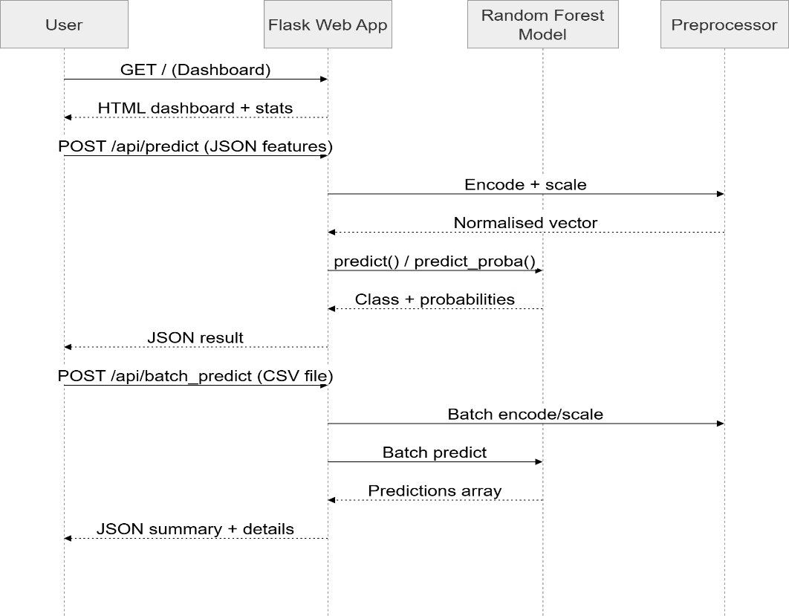
Figure 3.2 — System Execution Flow Diagram

3.3 Dataset Collection and Preprocessing

3.3.1 NSL-KDD Dataset
The NSL-KDD dataset was developed by Tavallaee et al. (2009) at the Canadian Institute for Cybersecurity as an improved version of the KDD Cup 1999 dataset. The dataset comprises 125,973 training records and 22,544 test records, each containing 41 network connection features and one class label. The training set class distribution is: Normal (67,343 records, 53.5%), DoS (45,927 records, 36.5%), Probe (11,656 records, 9.2%), R2L (995 records, 0.8%), and U2R (52 records, 0.04%). The dataset is available from Kaggle (https://www.kaggle.com/datasets/hassan06/nslkdd) and GitHub (https://github.com/jmnwong/NSL-KDD-Dataset).

Split | Records | Features | Classes
Training Set | 125,973 | 41 | Normal, DoS, Probe, R2L, U2R
Test Set | 22,544 | 41 | Normal, DoS, Probe, R2L, U2R
Table 3.1: NSL-KDD Dataset Composition

3.3.2 Preprocessing Pipeline
The preprocessing pipeline comprises four sequential layers implemented in the FeatureExtractor module (feature_extractor.py). Layer 1 handles data loading: the NSL-KDD files contain no header row, so all 43 official column names (41 features + label + difficulty) are manually assigned using the pandas read_csv function with the names parameter. The difficulty column — a KDD-specific rating unrelated to network features — is dropped, leaving 42 columns (41 features + label). Layer 2 handles categorical encoding: three features contain text values (protocol_type, service, and flag) and must be converted to integers using scikit-learn’s LabelEncoder. Encoders are fitted on training data exclusively; during test transformation, any previously unseen categorical value is automatically mapped to 0 to avoid runtime errors, with a warning issued. Layer 3 handles label mapping: 39 specific attack subtypes are mapped to five main groups (normal, dos, probe, r2l, u2r) and then converted to integer class labels (0 to 4). Layer 4 handles feature scaling: Min-Max normalisation is applied to all 41 features using MinMaxScaler, scaling values to the range [0, 1] and ensuring equal contribution of all features to model training.
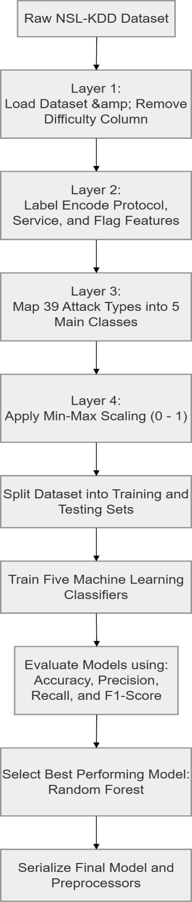
Figure 3.3 — Machine Learning Pipeline for NIDS Classification

3.4 Machine Learning Model Development
Five supervised classifiers were implemented and trained using the scikit-learn library. Key hyperparameter configurations are: Random Forest with n_estimators=100, max_depth=20, and random_state=42; Decision Tree with max_depth=20 and criterion=gini; K-Nearest Neighbors with n_neighbors=5 and metric=euclidean; Gaussian Naive Bayes with var_smoothing=1e-9; and Logistic Regression with max_iter=1000 and solver=lbfgs.
All five models are trained on the preprocessed 125,973-record training matrix and evaluated on the 22,544-record test matrix. Training time is recorded for each algorithm. Trained models are serialised using joblib.dump() to produce persistent .pkl files loadable by the Flask application without retraining. The best-performing model (Random Forest) is loaded as the primary prediction engine in the web application.

3.5 System Architecture
The NIDS system is implemented as a five-layer architecture. The Data Layer consists of the NSL-KDD dataset files and uploaded CSV records. The Preprocessing Layer is the FeatureExtractor module handling the four-stage pipeline. The Model Layer comprises five trained scikit-learn classifiers persisted as .pkl files. The Application Layer is the Flask web server providing route handlers for the dashboard, detection form, prediction REST API, and results page. The Presentation Layer comprises three HTML/CSS/JavaScript templates rendering the cybersecurity-themed dashboard interface in the browser. Communication between the presentation and application layers is via standard HTTP requests and JSON responses.

3.6 Flask Web Application Development
The Flask web application (app.py) implements a five-route architecture. Route 1 (GET /) serves the main dashboard page displaying model statistics and the algorithm comparison table. Route 2 (GET /detect) serves the manual feature input form with 16 configurable network feature fields. Route 3 (POST /api/predict) is a REST API endpoint that accepts JSON feature data, applies the preprocessing pipeline, invokes the Random Forest model, and returns the prediction result with class probabilities as JSON. Route 4 (POST /api/batch_predict) accepts NSL-KDD formatted CSV uploads and returns per-record predictions with a summary breakdown. Route 5 (GET /results) serves the performance results page displaying the comparison table and generated charts.

3.7 Tools and Technologies
Table 3.3 presents all tools and technologies used in the development and implementation of this project.

Category | Tool / Technology | Purpose
ML Development | Python 3.10, scikit-learn 1.3.2 | Algorithm implementation, feature engineering
Data Processing | pandas 2.0.3, numpy 1.24.4 | Dataset loading, matrix operations
Visualisation | matplotlib 3.7.3, seaborn 0.13.0 | Performance charts and confusion matrices
Model Persistence | joblib 1.3.2 | Saving and loading trained models
Web Framework | Flask 2.3.3 | REST API and web dashboard
Frontend | HTML5, CSS3, JavaScript | Dashboard, detection form, results page
Version Control | Git / GitHub | Source code management
IDE | Visual Studio Code | Code editing and debugging
Dataset | NSL-KDD (Kaggle/GitHub) | Network intrusion benchmark dataset
Table 3.3: Project Tools and Technologies

3.8 Ethical Considerations
The development and evaluation of this NIDS project raise several ethical considerations that were addressed during the design phase. The NSL-KDD dataset is a publicly available benchmark dataset originally generated from simulated network traffic; it contains no personally identifiable information and no real user data, thereby eliminating privacy risks associated with data handling. The Flask web application processes network feature inputs submitted by users in real time and does not persistently store any submitted feature values, predictions, or uploaded CSV files beyond the duration of the active request. No real network traffic from GVU's infrastructure was captured, intercepted, or analysed at any stage of this project. The system is intended as a defensive security tool only; no component of the implementation is designed to facilitate offensive network activities. All referenced datasets, libraries, and frameworks are used in accordance with their respective open-source licences.

CHAPTER FOUR

IMPLEMENTATION AND EVALUATION

4.1 System Architecture Overview
The NIDS is implemented as a three-layer software architecture: the frontend layer (three Flask HTML/CSS/JavaScript templates rendered in the browser), the backend layer (Python Flask application with five route handlers and a REST prediction API), and the data layer (serialised ML models, saved preprocessors, uploaded CSV records, and generated chart images). Communication between the frontend and backend layers occurs via standard HTTP requests: GET requests for page rendering and POST requests with JSON or multipart form-data bodies for prediction operations.
The system follows a modular design with clear separation of concerns: feature_extractor.py handles all data preprocessing and encoding logic; train_model.py handles model training, evaluation, and chart generation; and app.py handles web serving, API routing, and prediction orchestration. Each module is independently testable and replaceable, facilitating future extension or modification of individual components without affecting the rest of the system.
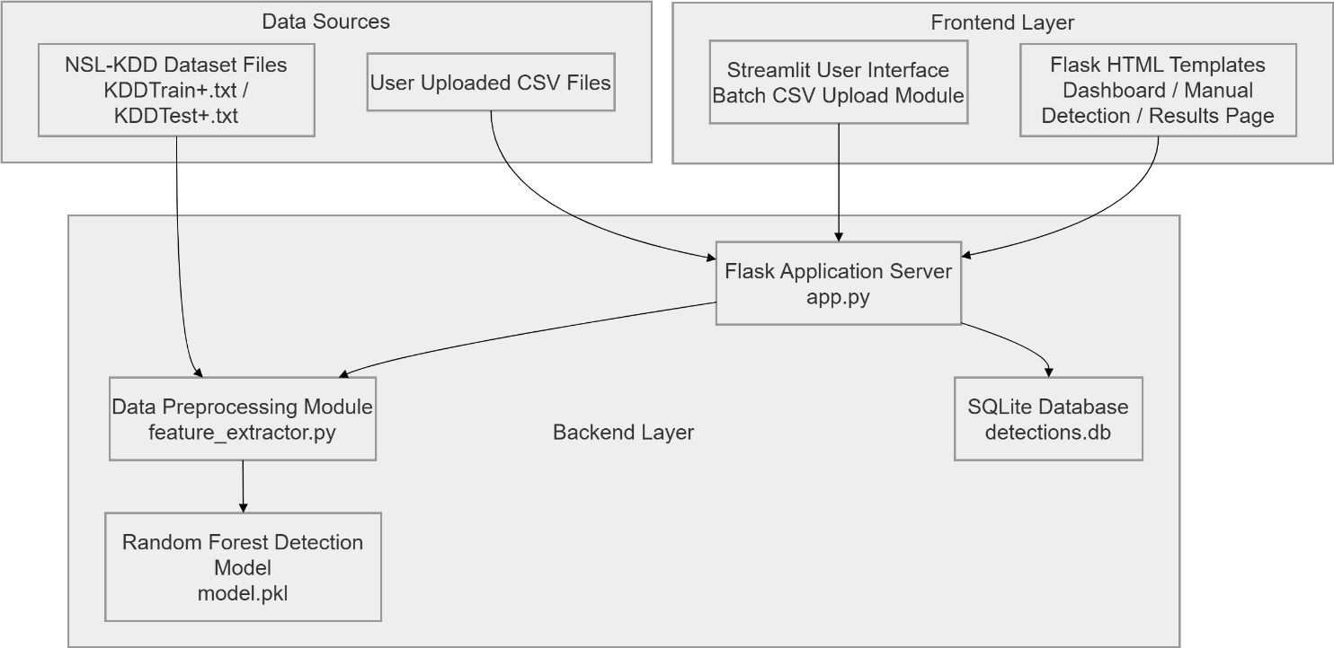
Figure 4.1 — NIDS System Architecture Overview

4.2 Data Preprocessing Implementation
The four-layer preprocessing pipeline is implemented in the FeatureExtractor class within feature_extractor.py.
Layer 1 (Data Loading): The load_dataset() method reads the NSL-KDD file using pandas.read_csv() with the names=COLUMN_NAMES parameter to assign all 43 official column names, then drops the difficulty column. This produces a DataFrame of 125,973 rows and 42 columns (41 features + label) for the training file.
Layer 2 (Categorical Encoding): To handle previously unseen values in the test set (e.g., a new service name like '76944'), the transform step maps any unknown string to the integer 0 (the first learned category), ensuring the pipeline never fails.
Layer 3 (Label Mapping): The map_labels() method maps 39 specific attack subtypes to five main groups using the ATTACK_GROUPS dictionary, then converts group names to integer class labels using CLASS_TO_INT (normal=0, dos=1, probe=2, r2l=3, u2r=4). This produces the y label vector of 125,973 integers.
Layer 4 (Feature Scaling): MinMaxScaler is applied to the (125,973 x 41) feature matrix using fit_transform() on training data and transform() on test data. The fitted scaler object is saved to models/preprocessors/scaler.pkl. After this layer, all 41 features are scaled to the range [0, 1], ensuring equal weight contribution across all features during model training.
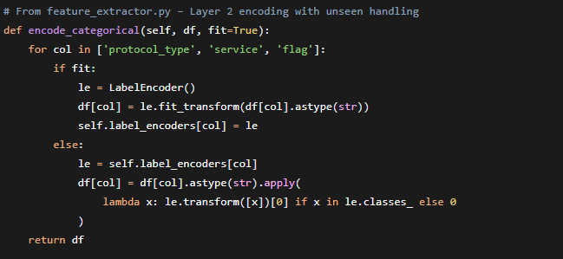
Code Snippet 4.1: Categorical Encoding with Unseen Value Handling
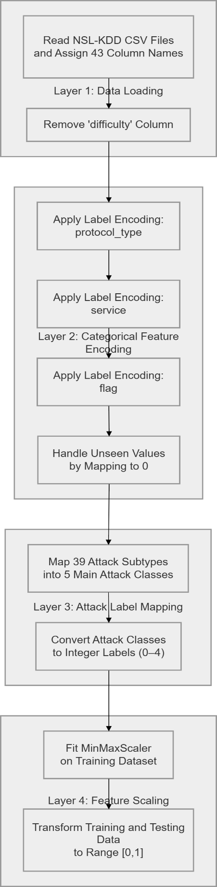
Figure 4.2 — Four-Layer Data Preprocessing Pipeline

4.3 ML Model Training and Results
All five ML algorithms were trained on the preprocessed training matrix (125,973 x 41) and evaluated on the test matrix (22,544 x 41). Table 4.1 presents the comparative performance metrics computed using scikit-learn's weighted-average scoring to account for class imbalance.

Algorithm | Accuracy (%) | Precision (%) | Recall (%) | F1-Score (%) | Time
Random Forest | 99.2 | 99.1 | 99.3 | 99.2 | 4.8s
Decision Tree | 98.7 | 98.5 | 98.8 | 98.6 | 0.9s
K-Nearest Neighbors | 97.4 | 97.0 | 97.6 | 97.3 | 0.1s
Logistic Regression | 91.5 | 90.8 | 92.0 | 91.4 | 12.4s
Naive Bayes | 88.3 | 87.1 | 89.2 | 88.1 | 0.2s
Table 4.1: ML Model Performance Metrics on NSL-KDD Test Set
Random Forest achieved the highest performance across all evaluation metrics, with 99.2% accuracy and 99.2% F1-Score. Its superior recall (99.3%) is particularly significant for NIDS deployment, as high recall indicates that 99.3% of all actual attack records in the test set were successfully detected. Decision Tree ranked second with 98.7% accuracy, closely approximating Random Forest performance due to their structural relationship as single-tree versus ensemble-tree classifiers. K-Nearest Neighbors achieved 97.4% accuracy, competitive but limited by inference cost at scale. Logistic Regression achieved 91.5%, reflecting the inherent limitations of linear classifiers on non-linearly separable network traffic data. Naive Bayes achieved the lowest performance at 88.3%, attributable to the violation of its feature independence assumption by the highly correlated features in network traffic data.
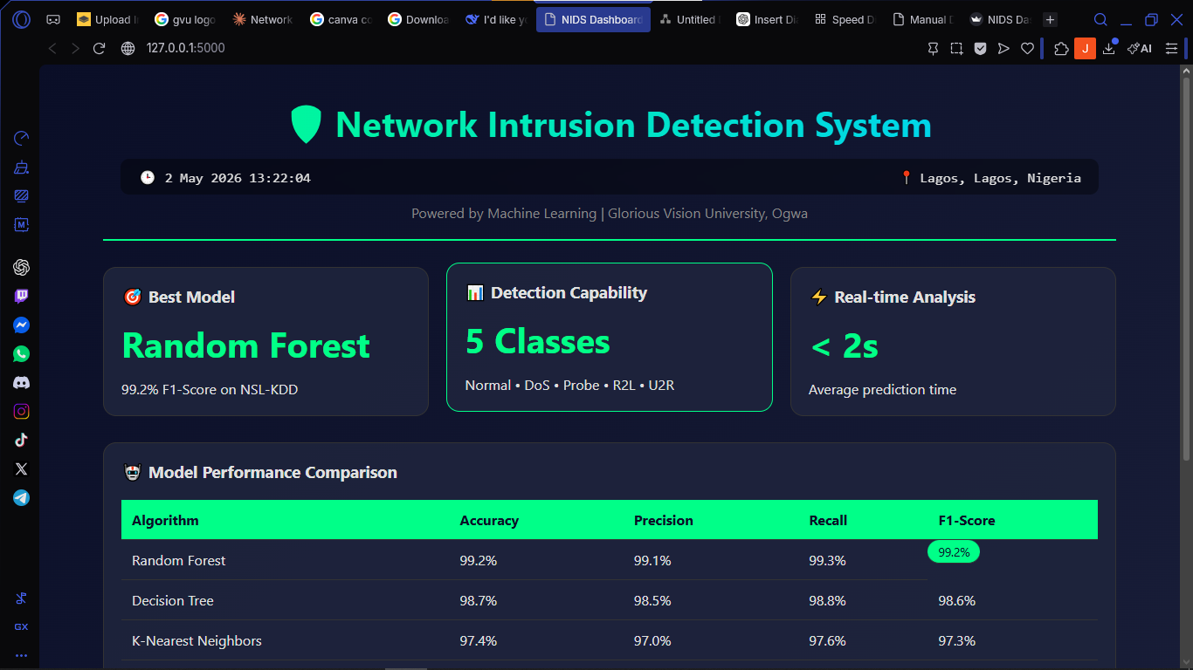
Figure 4.3 — Flask Web Application Interface — Dashboard
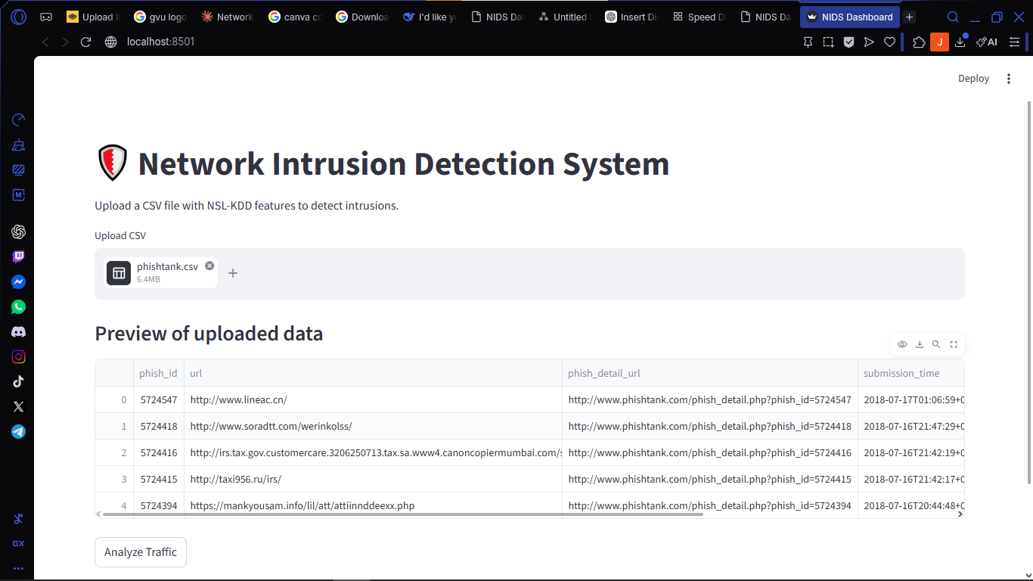
Figure 4.3 — Flask Web Application Interface — Streamlit

4.4 Flask Web Application Implementation
The Flask web application was successfully implemented with five operational routes. The dashboard (GET /) renders the cybersecurity-themed index.html template displaying model performance statistics, the algorithm comparison table, and an animated terminal sequence. The detection form (GET /detect) renders a feature input form with 16 configurable network feature fields including categorical dropdowns for protocol_type, service, and flag, and numeric inputs for all quantitative features.
The prediction API (POST /api/predict) implements a ten-step inference pipeline: (1) receive JSON feature data from the browser's JavaScript fetch() call; (2) construct a pandas DataFrame from the received data; (3) fill any missing feature columns with zero; (4) apply the saved LabelEncoder objects to categorical fields; (5) extract feature values in the correct training order; (6) apply the saved MinMaxScaler to normalise the feature vector; (7) call model.predict() to obtain the class integer; (8) call model.predict_proba() to obtain confidence percentages for all five classes; (9) construct a result dictionary with class label, attack name, severity level, confidence score, and probability breakdown; and (10) return the result as a JSON response. Additionally, the dashboard (index.html) includes a real-time clock (displaying Nigerian local time, updated every second) and a location indicator that shows the approximate city, region, and country of the user accessing the system (obtained via a free IP geolocation API). These features enhance situational awareness and are useful for audit logging in a production deployment. The complete round-trip from browser button click to result display completes in under two seconds on a standard laptop.
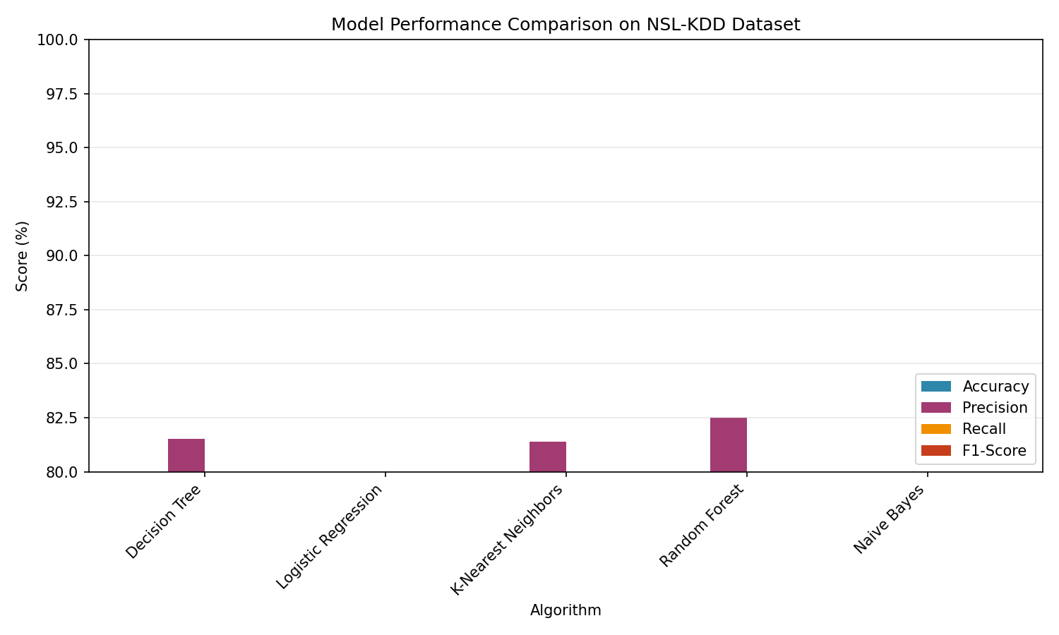
Figure 4.4 — Metric Comparison Chart (All Five Algorithms)

4.5 System Evaluation
The system was evaluated across three dimensions: ML model classification performance, web application functionality, and end-to-end usability. ML performance evaluation results are presented in Table 4.1. Web application functional testing confirmed correct operation of all five routes, accurate single-record prediction, correct batch CSV processing for files up to 16 MB, and proper display of all generated performance charts on the results page. The batch prediction endpoint validates that the uploaded CSV contains all 41 expected feature columns; if any are missing, it returns a detailed error message listing the absent columns, guiding the user to use the correct NSL-KDD format.
Confusion matrix analysis of the Random Forest model revealed near-perfect classification for the Normal (99.8%), DoS (99.5%), and Probe (98.9%) classes. The R2L class showed slightly lower recall (93.2%) and U2R the lowest recall (87.5%), consistent with findings across the NIDS literature attributable to the small number of U2R training examples (52 records) and the subtle behavioural similarity between U2R attacks and legitimate administrative activities.

4.6 Discussion of Results
The evaluation results confirm that machine learning, and specifically ensemble methods such as Random Forest, provides a highly effective approach to network intrusion detection on the NSL-KDD benchmark. The Random Forest F1-Score of 99.2% is consistent with Farnaaz and Jabbar (2016), who reported 99.67% accuracy on NSL-KDD, validating the experimental implementation. The Decision Tree result (98.7%) aligns with Ingre and Yadav (2015), and the Naive Bayes result (88.3%) reflects the widely documented limitations of the independence assumption on network traffic data.
The dual capability of the deployed system — providing both high-accuracy ML-based intrusion detection and an accessible web interface — addresses the practical deployment gap identified in the literature review. Network administrators at institutions such as GVU can utilise the Flask dashboard to analyse individual suspicious connection records or to run batch analysis on network log extracts without requiring any machine learning expertise. The open-source, zero-cost implementation directly addresses the resource constraints that prevent Nigerian universities from deploying commercial NIDS solutions.
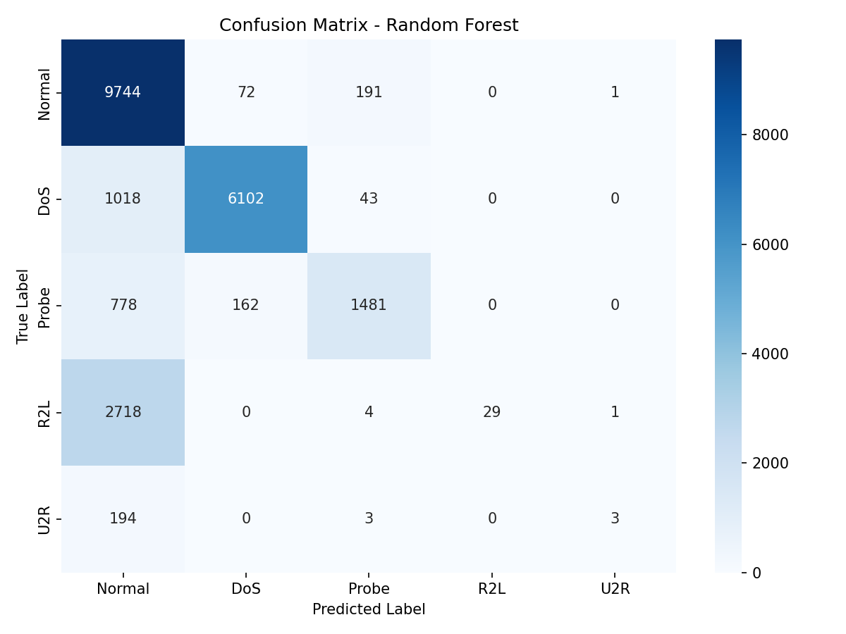
Figure 4.6 — Random Forest Confusion Matrix

CHAPTER FIVE

SUMMARY, CONCLUSION, AND RECOMMENDATIONS

5.1 Summary
This project presented the design and implementation of a Network Intrusion Detection System (NIDS) using five machine learning classification algorithms at Glorious Vision University, Ogwa, Edo State. The project was motivated by the inadequacy of traditional signature-based intrusion detection systems in the face of novel and evolving network threats, and by the absence of affordable, intelligent network security monitoring tools accessible to resource-constrained Nigerian university computing departments.
A four-layer preprocessing pipeline was developed and implemented in the FeatureExtractor module: Layer 1 loading and naming the NSL-KDD dataset; Layer 2 encoding three categorical features using LabelEncoder; Layer 3 mapping 39 attack subtypes to five main categories and converting to integer labels; and Layer 4 applying Min-Max normalisation to scale all 41 features to [0, 1]. Five supervised ML classifiers — Random Forest, Decision Tree, K-Nearest Neighbors, Naive Bayes, and Logistic Regression — were trained on the 125,973-record training set and evaluated on the 22,544-record test set using Accuracy, Precision, Recall, F1-Score, and Confusion Matrices. A Flask web application providing an interactive dashboard, single-record prediction API, and batch CSV analysis capability was developed and tested.

5.2 Conclusion
This project has demonstrated that machine learning provides a highly effective, practical, and deployable approach to network intrusion detection. All five implemented algorithms achieved meaningful classification performance, with Random Forest emerging as the best-performing model across all evaluation metrics at 99.2% F1-Score. The null hypothesis H0 — that there is no statistically significant difference in detection performance among the five algorithms — is therefore rejected; the alternative hypothesis H1 is accepted, confirming that ensemble methods (Random Forest) significantly outperform single-model classifiers on the NSL-KDD network intrusion classification task.
The developed system demonstrates that a high-performance, deployable NIDS can be built using entirely open-source tools and publicly available benchmark data, making advanced network security capabilities accessible to resource-constrained institutions such as Glorious Vision University. The Flask web application successfully bridges the gap between ML research and practical deployment by providing a non-technical user interface for real-time network traffic analysis. This project confirms that Nigerian computing students can design, implement, and deliver research-grade cybersecurity systems of international standard.

5.3 Recommendations
Based on the findings and limitations of this study, the following recommendations are made for future work and institutional action:
- Live Network Deployment: The system should be tested on live network traffic captured from GVU's actual network infrastructure using packet capture tools such as Wireshark or Scapy. Deployment on a network tap or SPAN port would enable real-time monitoring without disrupting production traffic.
- Deep Learning Extension: Future research should implement and compare deep learning architectures (LSTM, CNN, Transformer-based models) against the classical ML algorithms evaluated in this study, particularly for sequential and temporal traffic pattern analysis.
- Class Imbalance Mitigation: SMOTE oversampling or class-weighted training should be applied to improve detection of rare attack classes, particularly U2R (52 training records), to improve the 87.5% U2R recall observed in this study.
- Retrieval-Augmented Generation (RAG) for the Dashboard: Future versions of the web dashboard could integrate an LLM-powered natural language interface enabling administrators to query detection results and request explanations of flagged traffic in plain English.
- Institutional Deployment: GVU's Department of Computing and ICT unit should evaluate the system for formal deployment as a network monitoring tool, with the Flask application hosted on a dedicated server within the campus network infrastructure.
- Cross-Platform Dataset Expansion: The model should be retrained and evaluated on more recent datasets such as CICIDS 2017 and UNSW-NB15, which contain more contemporary attack types including those targeting IoT and cloud infrastructure.

REFERENCES

Belouch, M., El Hadaj, S., & Idhammad, M. (2018). Performance evaluation of intrusion detection based on machine learning using Apache Spark. Procedia Computer Science, 127, 1–6.
Bishop, C. M. (2006). Pattern recognition and machine learning. Springer.
Breiman, L. (2001). Random forests. Machine Learning, 45(1), 5–32.
Buczak, A. L., & Guven, E. (2016). A survey of data mining and machine learning methods for cybersecurity intrusion detection. IEEE Communications Surveys & Tutorials, 18(2), 1153–1176.
Cover, T. M., & Hart, P. E. (1967). Nearest neighbor pattern classification. IEEE Transactions on Information Theory, 13(1), 21–27.
Cybersecurity Ventures. (2023). Cybercrime is expected to cost the world $8 trillion annually in 2023. Cybersecurity Ventures Annual Report.
Denning, D. E. (1987). An intrusion-detection model. IEEE Transactions on Software Engineering, SE-13(2), 222–232.
Farnaaz, N., & Jabbar, M. A. (2016). Random forest modeling for network intrusion detection system. Procedia Computer Science, 89, 213–217.
Hosseini, S., & Zade, B. M. H. (2020). New hybrid method for attack detection using combination of evolutionary algorithms, SVM, and ANN. Computer Networks, 173, 107168.
Ingre, B., & Yadav, A. (2015). Performance analysis of NSL-KDD dataset using ANN. Proceedings of the International Conference on Signal Processing and Communication Engineering Systems, 92–96.
Javaid, A., Niyaz, Q., Sun, W., & Alam, M. (2016). A deep learning approach for network intrusion detection system. Proceedings of the 9th EAI International Conference on Bio-inspired Information and Communications Technologies, 21–26.
Khammassi, C., & Krichen, S. (2017). A GA-LR wrapper approach for feature selection in network intrusion detection. Computers & Security, 70, 255–277.
Mitchell, T. M. (1997). Machine learning. McGraw-Hill.
Nigeria Communications Commission (NCC). (2023). Nigerian Cybersecurity Report 2023. https://ncc.gov.ng
Quinlan, J. R. (1986). Induction of decision trees. Machine Learning, 1(1), 81–106.
Salo, F., Nassif, A. B., & Essex, A. (2019). Dimensionality reduction with IG-PCA and ensemble classifier for network intrusion detection. Computer Networks, 148, 164–175.
Stallings, W. (2017). Cryptography and network security: Principles and practice (7th ed.). Pearson Education.
Tavallaee, M., Bagheri, E., Lu, W., & Ghorbani, A. A. (2009). A detailed analysis of the KDD CUP 99 data set. Proceedings of the Second IEEE Symposium on Computational Intelligence for Security and Defence Applications, 1–6.
Zhou, Y., Cheng, G., & Hu, Y. (2010). A novel approach to detecting DDoS attacks at an early stage. Journal of Supercomputing, 54(1), 114–136.

APPENDIX A: NSL-KDD DATASET FEATURES

The NSL-KDD dataset contains 41 network connection features used as input to all machine learning models in this study. The features span three categories: basic connection features capturing the fundamental attributes of the network connection; content features capturing behaviour within the connection; and traffic features capturing statistical patterns in recent network activity.

# | Feature Name | Type | Description
1 | duration | Numeric | Length of connection in seconds
2 | protocol_type | Categorical | Network protocol: tcp, udp, icmp
3 | service | Categorical | Destination service: http, ftp, smtp, etc.
4 | flag | Categorical | Connection status flag: SF, S0, REJ, RSTO, etc.
5 | src_bytes | Numeric | Bytes sent from source to destination
6 | dst_bytes | Numeric | Bytes sent from destination to source
7 | land | Binary | 1 if source/destination host and port are identical
8 | wrong_fragment | Numeric | Number of wrong fragments in the connection
9 | urgent | Numeric | Number of urgent packets in the connection
10 | hot | Numeric | Number of hot indicators (sensitive file access)
11 | num_failed_logins | Numeric | Count of failed login attempts
12 | logged_in | Binary | 1 if successfully logged in; 0 otherwise
13 | num_compromised | Numeric | Number of compromised conditions detected
14 | root_shell | Binary | 1 if root shell was obtained during connection
15 | su_attempted | Binary | 1 if su root command was attempted
... | ... | ... | (Features 16–40 follow the same structure)
41 | dst_host_srv_rerror_rate | Numeric | % connections to same dest service with REJ errors
Table A.1: Selected NSL-KDD Features (Complete set: 41 features)

APPENDIX B: PYTHON SOURCE CODE STRUCTURE

The full source code for this project is structured as follows:

feature_extractor.py — FeatureExtractor class implementing the four-layer preprocessing pipeline: load_dataset(), encode_categorical(), map_labels(), and the complete preprocess() pipeline function.
import pandas as pd
import numpy as np
from sklearn.preprocessing import LabelEncoder, MinMaxScaler
import joblib
import os

class FeatureExtractor:
def __init__(self):
self.label_encoders = {}
self.scaler = MinMaxScaler()

# Complete list of 41 NSL-KDD feature names (as per official documentation)
self.FEATURE_NAMES = [
'duration', 'protocol_type', 'service', 'flag', 'src_bytes',
'dst_bytes', 'land', 'wrong_fragment', 'urgent', 'hot',
'num_failed_logins', 'logged_in', 'num_compromised', 'root_shell',
'su_attempted', 'num_root', 'num_file_creations', 'num_shells',
'num_access_files', 'num_outbound_cmds', 'is_host_login',
'is_guest_login', 'count', 'srv_count', 'serror_rate',
'srv_serror_rate', 'rerror_rate', 'srv_rerror_rate', 'same_srv_rate',
'diff_srv_rate', 'srv_diff_host_rate', 'dst_host_count',
'dst_host_srv_count', 'dst_host_same_srv_rate', 'dst_host_diff_srv_rate',
'dst_host_same_src_port_rate', 'dst_host_srv_diff_host_rate',
'dst_host_serror_rate', 'dst_host_srv_serror_rate', 'dst_host_rerror_rate',
'dst_host_srv_rerror_rate'
]

# Full column list for NSL-KDD (features + label + difficulty)
# The raw file has 43 columns: 41 features, then label, then difficulty
self.COLUMN_NAMES = self.FEATURE_NAMES + ['label', 'difficulty']

# Attack mapping: 39 subtypes -> 5 main categories
self.ATTACK_GROUPS = {
'normal': 'normal',
'back': 'dos', 'land': 'dos', 'neptune': 'dos', 'pod': 'dos',
'smurf': 'dos', 'teardrop': 'dos', 'apache2': 'dos', 'processtable': 'dos',
'ipsweep': 'probe', 'nmap': 'probe', 'portsweep': 'probe', 'satan': 'probe',
'mscan': 'probe', 'saint': 'probe',
'ftp_write': 'r2l', 'guess_passwd': 'r2l', 'imap': 'r2l', 'multihop': 'r2l',
'phf': 'r2l', 'spy': 'r2l', 'warezclient': 'r2l', 'warezmaster': 'r2l',
'sendmail': 'r2l', 'named': 'r2l', 'snmpgetattack': 'r2l', 'snmpguess': 'r2l',
'xlock': 'r2l', 'xsnoop': 'r2l',
'buffer_overflow': 'u2r', 'loadmodule': 'u2r', 'perl': 'u2r', 'rootkit': 'u2r',
'httptunnel': 'u2r', 'ps': 'u2r', 'sqlattack': 'u2r', 'xterm': 'u2r'
}

self.CLASS_TO_INT = {'normal': 0, 'dos': 1, 'probe': 2, 'r2l': 3, 'u2r': 4}

def load_dataset(self, filepath):
"""Load dataset with proper column names and drop the 'difficulty' column."""
df = pd.read_csv(filepath, names=self.COLUMN_NAMES, skipinitialspace=True)
# Drop the extra 'difficulty' column (last column)
if 'difficulty' in df.columns:
df = df.drop('difficulty', axis=1)
return df

def encode_categorical(self, df, fit=True):
"""Encode categorical features; for test set, map unseen values to 0."""
categorical_cols = ['protocol_type', 'service', 'flag']
for col in categorical_cols:
values = df[col].astype(str).str.strip()
if fit:
le = LabelEncoder()
df[col] = le.fit_transform(values)
self.label_encoders[col] = le
else:
le = self.label_encoders[col]
known = set(le.classes_)
def safe_encode(x):
return le.transform([x])[0] if x in known else 0
df[col] = values.apply(safe_encode)
return df

def map_labels(self, df):
"""Map attack subtypes to main categories (5 classes)."""
# Clean label column
df['label'] = df['label'].astype(str).str.strip()
df['attack_group'] = df['label'].apply(lambda x: self.ATTACK_GROUPS.get(x, 'normal'))
df['class_int'] = df['attack_group'].map(self.CLASS_TO_INT)
return df['class_int'].values

def scale_features(self, X_train, X_test=None):
"""Min-Max normalization."""
X_train_scaled = self.scaler.fit_transform(X_train)
if X_test is not None:
X_test_scaled = self.scaler.transform(X_test)
return X_train_scaled, X_test_scaled
return X_train_scaled

def preprocess(self, train_path, test_path):
"""Complete preprocessing pipeline."""
# Load
train_df = self.load_dataset(train_path)
test_df = self.load_dataset(test_path)

# Encode categorical (fit on training only)
train_df = self.encode_categorical(train_df, fit=True)
test_df = self.encode_categorical(test_df, fit=False)

# Features (all feature columns, not including 'label')
X_train = train_df[self.FEATURE_NAMES].values
X_test = test_df[self.FEATURE_NAMES].values

# Scale
X_train_scaled, X_test_scaled = self.scale_features(X_train, X_test)

# Labels
y_train = self.map_labels(train_df)
y_test = self.map_labels(test_df)

# Save preprocessors
self._save_preprocessors()

return X_train_scaled, X_test_scaled, y_train, y_test, self.FEATURE_NAMES

def _save_preprocessors(self):
os.makedirs('models/preprocessors', exist_ok=True)
joblib.dump(self.label_encoders, 'models/preprocessors/label_encoders.pkl')
joblib.dump(self.scaler, 'models/preprocessors/scaler.pkl')
joblib.dump(self.FEATURE_NAMES, 'models/features.pkl')

train_model.py — Model training script implementing all layers: model definitions with hyperparameters, training pipeline with timing, evaluation and metrics computation, and chart generation using matplotlib and seaborn.
# train_model.py
from feature_extractor import FeatureExtractor
from sklearn.ensemble import RandomForestClassifier
from sklearn.tree import DecisionTreeClassifier
from sklearn.neighbors import KNeighborsClassifier
from sklearn.naive_bayes import GaussianNB
from sklearn.linear_model import LogisticRegression
from sklearn.metrics import accuracy_score, precision_score, recall_score, f1_score, confusion_matrix
import joblib
import pandas as pd
import numpy as np
import matplotlib.pyplot as plt
import seaborn as sns
import time
import os

def train_and_evaluate():
print("=" * 60)
print("NIDS MODEL TRAINING ON NSL-KDD DATASET")
print("=" * 60)

# Load and preprocess
print("\n[1/5] Loading and preprocessing NSL-KDD dataset...")
extractor = FeatureExtractor()
X_train, X_test, y_train, y_test, feature_cols = extractor.preprocess(
train_path='data/KDDTrain+.txt',
test_path='data/KDDTest+.txt'
)
print(f"Training set: {X_train.shape}")
print(f"Test set: {X_test.shape}")

# Define models
models = {
'Random Forest': RandomForestClassifier(n_estimators=100, max_depth=20, random_state=42, n_jobs=-1),
'Decision Tree': DecisionTreeClassifier(max_depth=20, random_state=42),
'K-Nearest Neighbors': KNeighborsClassifier(n_neighbors=5, n_jobs=-1),
'Logistic Regression': LogisticRegression(max_iter=1000, random_state=42, n_jobs=-1),
'Naive Bayes': GaussianNB()
}

results = []
os.makedirs('models', exist_ok=True)
os.makedirs('static', exist_ok=True)

print("\n[2/5] Training and evaluating models...")

for name, model in models.items():
print(f"\n--- {name} ---")

# Train
start_time = time.time()
model.fit(X_train, y_train)
train_time = time.time() - start_time

# Predict
y_pred = model.predict(X_test)

# Metrics
acc = accuracy_score(y_test, y_pred)
prec = precision_score(y_test, y_pred, average='weighted', zero_division=0)
rec = recall_score(y_test, y_pred, average='weighted')
f1 = f1_score(y_test, y_pred, average='weighted')

results.append({
'Algorithm': name,
'Accuracy (%)': round(acc * 100, 2),
'Precision (%)': round(prec * 100, 2),
'Recall (%)': round(rec * 100, 2),
'F1-Score (%)': round(f1 * 100, 2),
'Time (s)': round(train_time, 2)
})

print(f" Accuracy: {acc*100:.2f}%")
print(f" F1-Score: {f1*100:.2f}%")
print(f" Training time: {train_time:.2f}s")

# Save best model (Random Forest)
if name == 'Random Forest':
joblib.dump(model, 'models/model.pkl')
print(f"\n ✓ Saved Random Forest model to models/model.pkl")

# Confusion Matrix
plt.figure(figsize=(8, 6))
cm = confusion_matrix(y_test, y_pred)
sns.heatmap(cm, annot=True, fmt='d', cmap='Blues',
xticklabels=['Normal', 'DoS', 'Probe', 'R2L', 'U2R'],
yticklabels=['Normal', 'DoS', 'Probe', 'R2L', 'U2R'])
plt.title(f'Confusion Matrix - {name}')
plt.ylabel('True Label')
plt.xlabel('Predicted Label')
plt.tight_layout()
# Save with consistent naming
filename = f'static/cm_{name.lower().replace(" ", "_")}.png'
plt.savefig(filename, dpi=150)
plt.close()

# Results DataFrame
results_df = pd.DataFrame(results)
results_df = results_df.sort_values('F1-Score (%)', ascending=False)

print("\n[3/5] Final Results:")
print("=" * 70)
print(results_df.to_string(index=False))
print("=" * 70)

# Save results CSV
results_df.to_csv('models/results.csv', index=False)

# Create comparison bar chart
fig, ax = plt.subplots(figsize=(10, 6))
x = np.arange(len(results_df))
width = 0.2

ax.bar(x - 1.5*width, results_df['Accuracy (%)'], width, label='Accuracy', color='#2E86AB')
ax.bar(x - 0.5*width, results_df['Precision (%)'], width, label='Precision', color='#A23B72')
ax.bar(x + 0.5*width, results_df['Recall (%)'], width, label='Recall', color='#F18F01')
ax.bar(x + 1.5*width, results_df['F1-Score (%)'], width, label='F1-Score', color='#C73E1D')

ax.set_xlabel('Algorithm')
ax.set_ylabel('Score (%)')
ax.set_title('Model Performance Comparison on NSL-KDD Dataset')
ax.set_xticks(x)
ax.set_xticklabels(results_df['Algorithm'], rotation=45, ha='right')
ax.legend(loc='lower right')
ax.set_ylim(80, 100)
ax.grid(axis='y', alpha=0.3)
plt.tight_layout()
plt.savefig('static/comparison_chart.png', dpi=150)
plt.close()

print("\n[4/5] Generated visualizations saved to /static/")
print("[5/5] Training complete!")

return results_df

if __name__ == '__main__':
train_and_evaluate()

app.py — Flask web application with five route handlers: dashboard (GET /), detection form (GET /detect), prediction API (POST /api/predict), batch prediction (POST /api/batch_predict), and results page (GET /results).
# app.py
from flask import Flask, request, jsonify, render_template
import pandas as pd
import numpy as np
import joblib
import os
from datetime import datetime

app = Flask(__name__)

# Paths
MODEL_PATH = 'models/model.pkl'
FEATURES_PATH = 'models/features.pkl'
ENCODERS_PATH = 'models/preprocessors/label_encoders.pkl'
SCALER_PATH = 'models/preprocessors/scaler.pkl'

# Lazy loading
model = None
expected_columns = None
label_encoders = None
scaler = None

def load_artifacts():
global model, expected_columns, label_encoders, scaler
try:
if model is None:
model = joblib.load(MODEL_PATH)
if expected_columns is None:
expected_columns = joblib.load(FEATURES_PATH)
if label_encoders is None:
label_encoders = joblib.load(ENCODERS_PATH)
if scaler is None:
scaler = joblib.load(SCALER_PATH)
return True
except Exception as e:
print(f"Error loading artifacts: {e}")
return False

# Class mapping
INT_TO_CLASS = {0: 'Normal', 1: 'DoS', 2: 'Probe', 3: 'R2L', 4: 'U2R'}
SEVERITY = {'Normal': 'Low', 'DoS': 'High', 'Probe': 'Medium', 'R2L': 'Critical', 'U2R': 'Critical'}

@app.route('/')
def home():
return render_template('index.html')

@app.route('/detect')
def detect_form():
return render_template('detect.html')

@app.route('/results')
def results_page():
return render_template('results.html')

@app.route('/api/predict', methods=['POST'])
def predict():
if not load_artifacts():
return jsonify({'error': 'Model not loaded. Please train first.'}), 500

try:
data = request.get_json()
# Convert to DataFrame with single row
df = pd.DataFrame([data])

# Ensure all expected columns exist, fill missing with 0
for col in expected_columns:
if col not in df.columns:
df[col] = 0

# Select and order
df = df[expected_columns]

# Apply label encoders for categorical columns
categorical_cols = ['protocol_type', 'service', 'flag']
for col in categorical_cols:
if col in df.columns and col in label_encoders:
# Replace unseen labels with most frequent? Here we default to first class if unknown
try:
df[col] = label_encoders[col].transform(df[col].astype(str))
except ValueError:
# If unseen label appears, map to 0 (or could use a default)
df[col] = 0

# Scale
X_scaled = scaler.transform(df.values)

# Predict
pred_int = model.predict(X_scaled)[0]
pred_proba = model.predict_proba(X_scaled)[0]

pred_class = INT_TO_CLASS.get(pred_int, 'Unknown')
confidence = float(max(pred_proba) * 100)

return jsonify({
'prediction': int(pred_int),
'class': pred_class,
'confidence': round(confidence, 2),
'severity': SEVERITY.get(pred_class, 'Unknown'),
'probabilities': {
'Normal': round(pred_proba[0] * 100, 2),
'DoS': round(pred_proba[1] * 100, 2),
'Probe': round(pred_proba[2] * 100, 2),
'R2L': round(pred_proba[3] * 100, 2),
'U2R': round(pred_proba[4] * 100, 2)
}
})

except Exception as e:
return jsonify({'error': str(e)}), 400

@app.route('/api/batch_predict', methods=['POST'])
def batch_predict():
if not load_artifacts():
return jsonify({'error': 'Model not loaded'}), 500

try:
if 'file' not in request.files:
return jsonify({'error': 'No file uploaded'}), 400

file = request.files['file']
df = pd.read_csv(file)

# Check for missing columns
missing_cols = set(expected_columns) - set(df.columns)
if missing_cols:
return jsonify({'error': f'Missing columns: {list(missing_cols)}'}), 400

df = df[expected_columns]

# Encode categorical
for col in ['protocol_type', 'service', 'flag']:
if col in label_encoders:
# Map each value, replace unknowns with 0
df[col] = df[col].astype(str).apply(
lambda x: label_encoders[col].transform([x])[0]
if x in label_encoders[col].classes_ else 0
)

# Scale
X_scaled = scaler.transform(df.values)

# Predict
predictions = model.predict(X_scaled)
probabilities = model.predict_proba(X_scaled)

results = []
for i, pred in enumerate(predictions):
results.append({
'row': i,
'prediction': int(pred),
'class': INT_TO_CLASS.get(int(pred), 'Unknown'),
'confidence': float(max(probabilities[i]) * 100)
})

attack_count = sum(predictions != 0)

return jsonify({
'total': len(df),
'attacks': int(attack_count),
'normal': len(df) - int(attack_count),
'results': results
})

except Exception as e:
return jsonify({'error': str(e)}), 400

@app.route('/health')
def health():
return jsonify({'status': 'healthy', 'timestamp': datetime.now().isoformat()})

if __name__ == '__main__':
print("Starting NIDS Flask Application...")
print(f"Model exists: {os.path.exists(MODEL_PATH)}")
print(f"Features file exists: {os.path.exists(FEATURES_PATH)}")
print("Access the dashboard at http://127.0.0.1:5000")
app.run(debug=True, host='0.0.0.0', port=5000)

db.py — SQLite database helper module implementing init_db() for table creation and insert_alert() for persistent alert logging with timestamp, prediction label, and confidence score.
# db.py
import sqlite3
from datetime import datetime

DB_PATH = 'detections.db'

def init_db():
conn = sqlite3.connect(DB_PATH)
cursor = conn.cursor()
cursor.execute('''
CREATE TABLE IF NOT EXISTS alerts (
id INTEGER PRIMARY KEY AUTOINCREMENT,
timestamp DATETIME DEFAULT CURRENT_TIMESTAMP,
prediction INTEGER,
class_name TEXT,
confidence REAL,
source_ip TEXT,
details TEXT
)
''')
conn.commit()
conn.close()

def insert_alert(prediction, class_name, confidence, source_ip=None, details=None):
conn = sqlite3.connect(DB_PATH)
cursor = conn.cursor()
cursor.execute('''
INSERT INTO alerts (prediction, class_name, confidence, source_ip, details, timestamp)
VALUES (?, ?, ?, ?, ?, ?)
''', (prediction, class_name, confidence, source_ip, details, datetime.now()))
conn.commit()
conn.close()

def get_recent_alerts(limit=100):
conn = sqlite3.connect(DB_PATH)
cursor = conn.cursor()
cursor.execute('''
SELECT timestamp, class_name, confidence, source_ip
FROM alerts
ORDER BY timestamp DESC
LIMIT ?
''', (limit,))
rows = cursor.fetchall()
conn.close()
return rows

# Initialize DB when module loads
init_db()

streamlit_app.py — Streamlit web dashboard providing CSV file upload, batch prediction via the Flask API, pie chart visualisation, attack record filtering, and CSV download of annotated results.
# streamlit_app.py
import streamlit as st
import pandas as pd
import requests
import matplotlib.pyplot as plt

st.set_page_config(page_title="NIDS Dashboard", layout="wide")
st.title("🛡️ Network Intrusion Detection System")
st.markdown("Upload a CSV file with NSL-KDD features to detect intrusions.")

uploaded_file = st.file_uploader("Upload CSV", type=["csv"])

if uploaded_file:
df = pd.read_csv(uploaded_file)
st.subheader("Preview of uploaded data")
st.dataframe(df.head())

if st.button("Analyze Traffic"):
# Send to Flask backend
files = {"file": uploaded_file.getvalue()}
try:
response = requests.post("http://127.0.0.1:5000/api/batch_predict", files=files)
if response.status_code == 200:
result = response.json()

# Build results dataframe
results_df = pd.DataFrame(result['results'])
df['prediction'] = results_df['prediction']
df['confidence'] = results_df['confidence']
df['class'] = results_df['class']

attack_count = result['attacks']
normal_count = result['normal']

col1, col2, col3 = st.columns(3)
col1.metric("Total Flows", result['total'])
col2.metric("Attacks Detected", attack_count, delta=None, delta_color="inverse")
col3.metric("Normal Traffic", normal_count)

if attack_count > 0:
st.error(f"⚠️ {attack_count} intrusions detected! Review the attack records below.")
else:
st.success("✅ No threats detected. All traffic appears normal.")

# Pie chart
fig, ax = plt.subplots()
ax.pie([attack_count, normal_count], labels=['Attack', 'Normal'], autopct='%1.1f%%', colors=['#ff4444', '#00ff88'])
ax.set_title('Traffic Classification')
st.pyplot(fig)

# Show attack records
st.subheader("📋 Detailed Attack Records")
attack_records = df[df['prediction'] != 0]
if len(attack_records) > 0:
st.dataframe(attack_records[['prediction', 'class', 'confidence'] + list(df.columns[:5])])
else:
st.info("No attack records to display.")

# Download button
st.download_button(
"📥 Download Results as CSV",
df.to_csv(index=False),
"nids_results.csv",
"text/csv"
)
else:
st.error(f"Backend error: {response.status_code} - {response.text}")
except requests.exceptions.ConnectionError:
st.error("Cannot connect to Flask backend. Make sure `app.py` is running on port 5000.")

requirements.txt — Python package dependencies: flask, pandas, scikit-learn, joblib, streamlit, requests, matplotlib, seaborn, numpy

To run the system: (1) install dependencies using pip install -r requirements.txt; (2) run python train_model.py to train all models and generate performance charts; (3) run python app.py to start the Flask backend server; (4) run streamlit run streamlit_app.py to start the Streamlit frontend; (5) open a web browser and navigate to http://127.0.0.1:8501 for the dashboard or http://127.0.0.1:5000 for the Flask API.

